**PROCEDURES FOR PARENTS TO FOLLOW**

If you have concerns about your child’s welfare,

What should you do?

* Contact your child’s teacher first of all;
* If the issue has not been resolved, please make arrangement to contact Mr Quinn;
* Should that fail to satisfy, please contact the Chair of Governors,

Mrs Teresa Nugent, via the school office.

A copy of the school’s Child Protection Policy is available from the school office on request.

At any time, you can contact a social worker

Tel**: 028 30 805000 Ext 1**

Or the Police Local Care Unit

**Contacts and Help lines**

NSPCC Child Protection Helpline 0800 800 500

NI Childline Tel: 028 90 32 7773

Childline UK Tel: 0800 1111

**St Patrick’s Primary**

**and Nursery School**

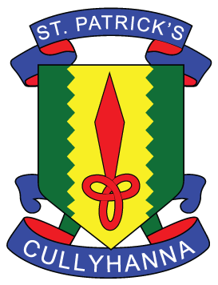

**Child Protection Policy**

**A summary Guide for Parents**

**CHILD PROTECTION**

We in St Patrick’s Primary school have a fundamental responsibility for the care, welfare and safety of the pupils in our charge and we aim to provide a caring, spiritual and safe environment for all pupils.

The United Nations Convention on the rights of the child states:

***“Children have the right to be protected from all forms of physical or mental violence, injury or abuse, neglect or negligent treatment, maltreatment or exploitation including sexual abuse by those looking after them; they must be kept safe from harm; and they must be given proper care by those looking after them.”***

The following approaches have been put in place to ensure the protection of all children. Staff are aware of these.

* All members of staff, trainees and school volunteers have been properly vetted before being engaged.
* Teaching and non-teaching staff are familiar with the Child Protection Policy and school procedures regarding protection issues. There is a code of conduct in place for staff.
* **The designated teacher is Mr Quinn. The deputy designated teachers are Mr Digney and Mrs Hollywood. Our school Governor responsible for Child Protection is Mrs Orla Mullen.**
* The school’s full Child Protection Policy is available from the Office for any parent wishing to seek further information.
* The school building and grounds are monitored by 24 hr CCTV and all main doors operate via a Security System
* Children are encouraged to report any incidences of bullying. These are promptly dealt with.

**PROCEDURES FOR THE SCHOOL**

If we have concerns about the welfare of your child, what are we required to do?

* In the majority of cases, we will ask to meet with you first to discuss our concerns;
* If the issue has not been resolved, we are obliged to consult with the appropriate agency;
* If we are advised to make a referral to Social Services, we must follow that advice;
* We will endeavour at all times to keep you informed.

The designated teacher is the Principal who is responsible for:

* Liaising with Trust Child Care Services and other relevant agencies;
* Individual cases of suspected child abuse, or;
* Where more general concerns exist about a child.

***In St Patrick’s, child abuse will not be ignored by anyone who works within the school and all staff recognise that certain forms of abuse are a criminal offence.***